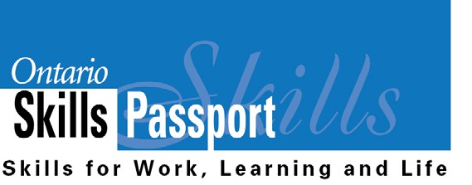
My Essential Skills - Primary
Group Assignment
Find someone who...

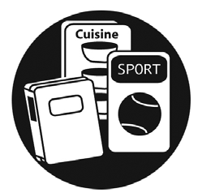  Loves looking at pictures and reading words they know in books! | 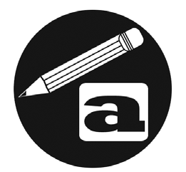  Loves to write (e.g., name, pictures, notes, stories)! | 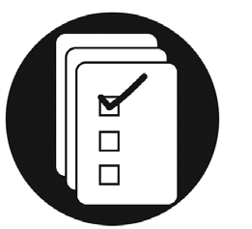  Can read signs in their community.

Can login and use a mouse on a computer. | Knows the names of coins and  how much they are worth. | 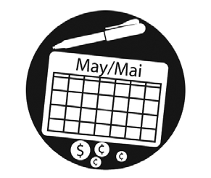  Can read their class schedule and plan when they need to study for a quiz.

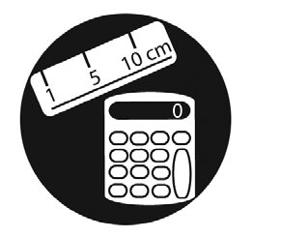  Can figure out how many plates and cups they need to set a table for their family. | Can judge if they have the appropriate art supplies to complete a project. | 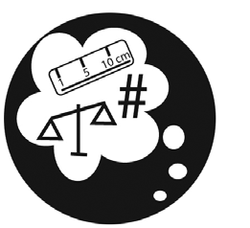  Can guess how many scoopfuls of sand they need to fill their pail.

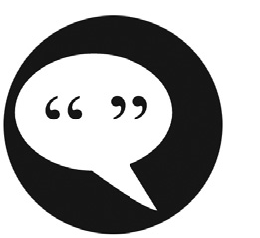  Can ask a friend or an adult for something they need. | 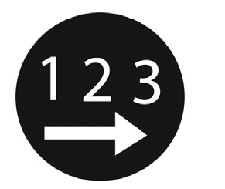  Can pack their backpack with the things they need for school. | 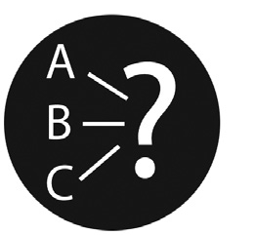  Can make choices about what clothing they will wear based on the weather forecast.

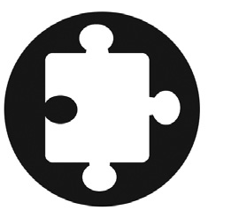  Loves doing puzzles and solving riddles! | Can ask an adult to help them find something (e.g., washroom or drinking fountain). | 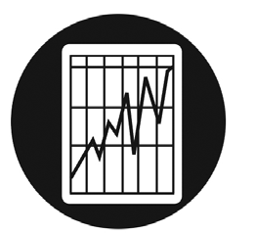  Can compare their marks on two assignments to determine whether their skills are improving.

